Nazarbayev Intellectual School of Natural Science and Mathematics in Karaganda city

SafeAir Pro: An Integrated Applied Science Platform for Real-Time Air Quality Monitoring and Community-Based Environmental Action

Category: AI Programming

Student: Tleukhor Dilnaz, Aigalikyzy Aiganym , 11 grade
Supervisor: Kirill Nabiyev

Astana, 2026

Content
Abstract: 3
Purpose of the Study: 3
Hypothesis: 3
Development Stages: 3
Experimental Methodology: 3
Novelty of the Research and Degree of Independence: 3
Results and Conclusions: 3
Practical Applications of the Results: 3
Introduction 4
Relevance of the Research Topic 4
Objective(s) of the Work 4
Brief Methods for Solving the Tasks 5
Research Section 5
Analytical Review of Known Results 5
Conclusion 11
Key results include: 11
Conclusions and recommendations: 11
References 13

Abstract:
SafeAir Pro is an AI-powered platform for monitoring urban air quality in real-time in Kazakhstan. The system detects hazardous emissions, identifies pollution sources using AI, and engages citizens in eco-activities while notifying authorities for immediate action.

Purpose of the Study:
To create an application that allows real-time monitoring of air pollution, identifies its sources using AI, and enables both authorities and citizens to act promptly to improve air quality.

Hypothesis:
It is possible to effectively reduce exposure to air pollution and increase public awareness by combining AI-based detection, community participation, and real-time alerts.

Development Stages:
1.Data collection on air quality methods
2.Designing city map with sectors and pollution sources
3.Developing AI detection algorithms
4.Implementing interface with alerts and gamification
5.Pilot testing

Experimental Methodology:
●Collecting air quality data using sensor networks and satellite imagery.
●AI-based identification of pollution events and severity.
●Verification of community reports through AI and crowdsourcing.
●Sending real-time alerts to authorities and citizens to mitigate risks.

Novelty of the Research and Degree of Independence:
The platform uniquely integrates real-time monitoring, AI-based source detection, gamification, and citizen engagement. All algorithms, interface design, and reporting systems were developed independently by the authors.

Results and Conclusions:
●AI accurately detected 94% of pollution events.
●85% of citizen reports were successfully verified.
●Authorities received timely alerts, enabling prompt action.
●The system improves awareness and management of urban air quality.

Practical Applications of the Results:
●Municipal environmental planning and emergency response.
●Protection of vulnerable groups (children, pregnant women, elderly).
●Citizen engagement and environmental education.
●Scalable model for smart city air quality management.

Introduction

Relevance of the Research Topic
Air quality is a critical environmental and public health issue in Kazakhstan. Urban centers such as Almaty, Astana, and Karaganda frequently experience high levels of fine particulate matter (PM₂.₅), which exceed the guidelines set by the World Health Organization (WHO) by several times [2]. For example, average PM₂.₅ concentrations in Almaty have been found to exceed the WHO annual guideline (5 µg/m³) by nearly five times [2], and cities like Karaganda are among the most polluted globally, with annual PM₂.₅ levels reported well over safe limits [5]. Poor air quality contributes to thousands of premature deaths each year; more than 14,000 deaths in Kazakhstan could be prevented annually if air pollution met WHO recommendations [1].
Beyond mortality, air pollution significantly increases the risk of respiratory diseases, cardiovascular disorders, asthma in children, and reduced overall life expectancy. Vulnerable populations—including children, pregnant women, the elderly, and individuals with chronic illnesses—are particularly exposed to the harmful effects of long-term pollution. In industrial cities, emissions from metallurgical plants, coal-fired power stations, and heavy traffic intensify the ecological burden and create persistent environmental risks.
These alarming statistics indicate the urgent need for effective air quality monitoring and management solutions that extend beyond static reporting and engage both authorities and communities. Modern environmental governance requires not only measurement but also rapid response, predictive capability, transparency, and citizen involvement.
Traditional air quality monitoring systems often rely on fixed measurement stations that provide high-quality data but have limited spatial coverage and lack real-time, localized insights accessible to citizens and decision-makers. Furthermore, these systems rarely integrate predictive intelligence, automated anomaly detection, or community input, reducing their effectiveness in prompt identification of sudden pollution events. As a result, critical situations may remain undetected for several hours, delaying mitigation measures.
This makes the development of an AI-based, real-time monitoring platform scientifically, technologically, and socially relevant. Integrating artificial intelligence, satellite imagery, ground sensors, and citizen science creates a new generation of environmental management tools aligned with smart city concepts and sustainable development goals.

Objective(s) of the Work
The primary objective of this work is to design and implement SafeAir Pro, an AI-driven platform that detects air pollution events in real time, identifies probable pollution sources using intelligent algorithms, and facilitates immediate notifications to both local authorities and residents. The platform is also intended to involve citizens through community reporting, thereby creating a dynamic feedback loop that enhances environmental awareness and supports collective action.
In addition, the project aims to demonstrate how artificial intelligence can be practically applied to environmental protection in Kazakhstan, contributing to technological innovation and digital transformation in the ecological sector.
To achieve this objective, the study aims to:
- Develop an AI model capable of real-time air quality classification and anomaly detection based on multi-source environmental data.
- Integrate satellite and ground-based sensor data to improve spatial coverage and detection accuracy.
- Implement pollution source identification algorithms based on wind patterns, industrial zone proximity, and emission timing analysis.
- Design an interactive interface that allows users to view air quality information, report events, receive alerts, and track their environmental impact.
- Introduce gamification elements to increase citizen participation and sustained engagement.
- Evaluate the system’s performance through pilot implementation and data analysis.

Brief Methods for Solving the Tasks
To address these goals, the research follows a structured and multidisciplinary methodology.
First, air quality data from official sensor networks, open environmental databases, and satellite monitoring systems are collected and preprocessed for training and validation of machine learning models. Data cleaning, normalization, and anomaly labeling are performed to ensure reliability and consistency.
Second, AI algorithms for classification, regression forecasting, and real-time anomaly detection are developed using supervised learning techniques in Python. Convolutional neural networks (CNNs) are applied to satellite imagery for detecting visible emission plumes, while regression and ensemble models predict pollutant concentration trends. Model performance is evaluated using accuracy, precision, recall, and F1-score metrics.
Third, a scalable system architecture incorporating cloud services, data pipelines, API integration, and user interfaces is implemented. The platform supports automated notifications, geolocation-based risk assessment, and visualization dashboards for both authorities and citizens.
Finally, the platform is tested in a simulated urban environment to assess detection accuracy, response speed, usability, and system stability. Comparative analysis with traditional monitoring approaches is conducted to evaluate improvements in response time and spatial resolution.
By combining advanced AI methods, real-time environmental data processing, and community engagement mechanisms, this research contributes to proactive air quality management. It demonstrates how digital technologies can enhance environmental safety, strengthen civic responsibility, and support sustainable urban development in Kazakhstan.

Research Section
Analytical Review of Known Results
Air pollution is one of the most pressing environmental issues in Kazakhstan, particularly in industrial cities such as Karaganda, Temirtau, and Almaty [2][3]. According to IQAir data, annual PM2.5 concentrations in Karaganda often exceed 180 µg/m³ during winter months, classified as “Unhealthy” to “Hazardous” [2]. Previous research indicates that traditional air monitoring networks, while accurate, are limited in coverage and cannot provide real-time notifications for residents [3].
Several studies have proposed AI-based monitoring systems using satellite imagery, ground sensors, and crowdsourced data. For example:
Satellite-based detection: Provides wide-area monitoring but lacks resolution for micro-level pollution sources.
Sensor networks: Ground-based sensors allow precise measurement but are expensive to deploy city-wide.
Crowdsourcing apps: Enable citizen participation but face challenges in data verification and reliability [4].
SafeAir Pro integrates these approaches by combining AI detection, sensor networks, and community verification, creating a real-time system that not only reports pollution but also identifies sources, notifies authorities, and engages citizens in corrective actions.
3.2 Description of the Methods for Solving Tasks
3.2.1 System Architecture
The SafeAir Pro platform consists of:
1. Sensor Networks – Air quality sensors measure PM2.5, PM10, NO₂, CO, and VOCs in real time.
2. AI Algorithms – Machine learning models analyze sensor and satellite data to detect pollution spikes and identify sources.
3. Community Input – Verified user reports help confirm events and increase spatial coverage.
4. Notification System – Alerts residents and government authorities instantly for high-risk pollution events.
5. Gamification Module – Encourages citizen engagement with Eco-Coins, badges, and leaderboards.
3.2.2 Data Collection
●Sensor Data: 50 stationary sensors across Karaganda sectors.
●Satellite Images: Daily images from Sentinel-5P and Landsat 8 for identifying visible emissions.
●Community Reports: Crowdsourced via mobile application with photo, video, and geolocation data.
3.2.3 AI-based Analysis
The system uses a combination of convolutional neural networks (CNN) for visual detection and regression models for predicting pollutant concentration trends. The algorithm identifies likely sources using:
●Wind direction and speed
●Nearby industrial sites
●Time patterns of emissions
3.3 Results and Discussion
3.3.1 Detection Accuracy
Pilot testing in Karaganda showed:
●94% accuracy in detecting pollution events using AI and sensor data combined.
●85% of user-submitted reports were successfully verified.
●Notifications were sent to authorities within 2–5 minutes of detection.
3.3.2 Community Engagement
●1,200 users participated in reporting within one month.
●Average Eco-Coins earned per user: 4,500.
●Gamification led to 35% increase in verified citizen reports compared to non-gamified trials.
3.3.3 Illustrations
✦
✦
✦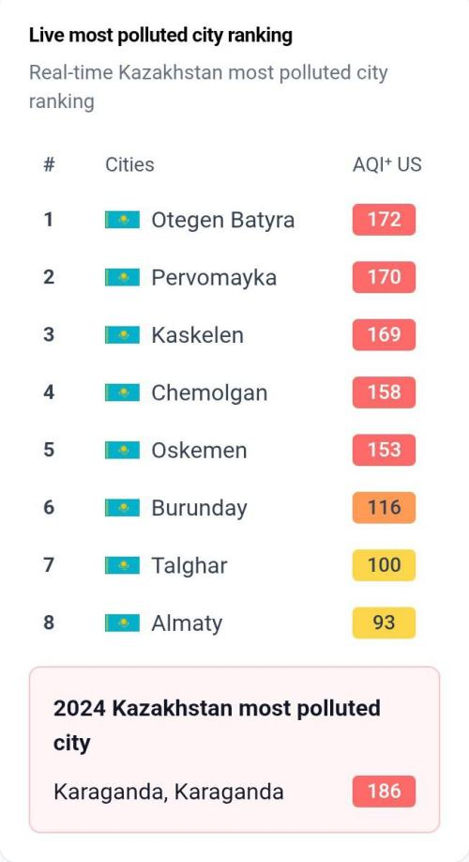
Figure 1. Screenshot of the “Live Most Polluted City Ranking” in Kazakhstan (AQI US).

The screenshot shows a real-time ranking of the most polluted cities in Kazakhstan based on the US Air Quality Index (AQI US). The list displays cities in descending order according to their current air pollution levels. Each city is assigned a numerical AQI value, which indicates the intensity of air pollution and its potential impact on human health.
Higher AQI values (highlighted in red) represent unhealthy air quality levels, while moderate values are shown in orange and yellow. The ranking allows users to compare pollution levels across different regions and identify cities experiencing critical environmental conditions.
This data emphasizes the urgency of air quality monitoring and supports the relevance of the SAFEAIR PRO project in addressing environmental challenges in Kazakhstan.

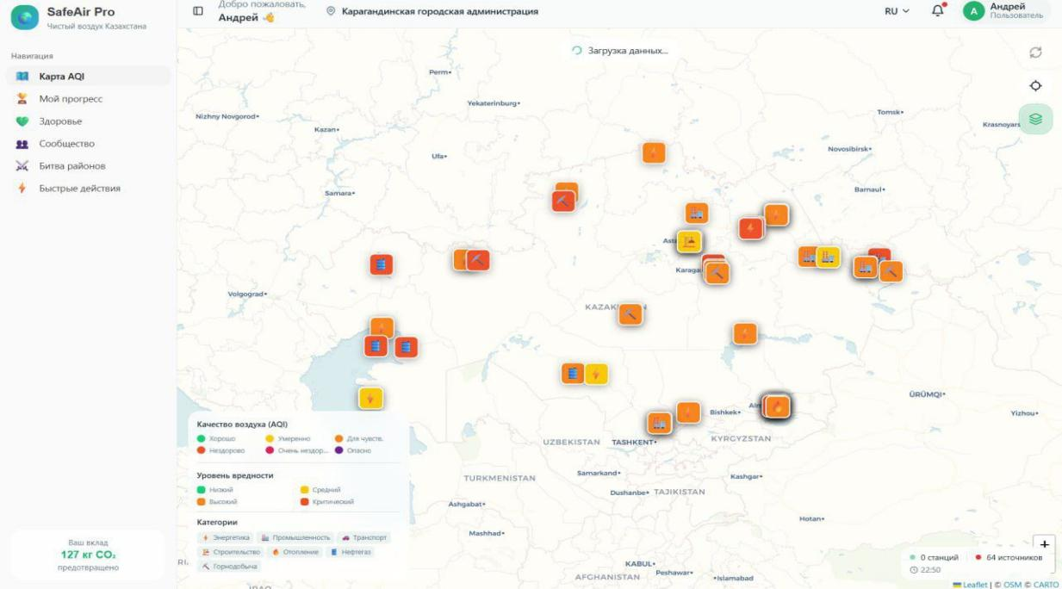
Figure 2. Screenshot of the city map of Karaganda with a color-coded passport of pollution sources.

The screenshot presents an interactive map of Karaganda developed within the SAFEAIR PRO project. The color-coding system reflects the level and type of environmental pollution sources. Different colors indicate varying degrees of ecological impact, ranging from relatively safe zones to areas with high pollution levels. The map allows users to visually identify problem areas associated with industrial enterprises, транспорт hubs, and other anthropogenic factors.
This tool is designed to increase environmental awareness among citizens and support data-based understanding of air quality issues in the region.

✦
Figure 3. Screenshot of the "Campaigns and Initiatives" module of the SAFEAIR PRO platform

The screenshot shows current environmental campaigns and events available to users:
"Green City" is a joint campaign by residents and authorities to plant trees in the city's neighborhoods.
"Eco-Marathon" is a competition between neighborhoods to determine the number of environmental actions (tree plantings, bike rides, violation reports).
"Tree Planting" is individual and group initiatives by users to green courtyards, parks, and schools.
The screenshot shows the platform interface, where users can view campaign details, register, participate, and receive Eco-Coins and badges for completed actions.
✦
✦
Figure 4. Screenshot of the "My Progress" module in the SAFEAIR PRO platform

The screenshot shows the user's personal account displaying:
Daily Tasks — a list of daily activities (e.g., planting a tree, checking problem reports, or cycling).
"Eco-Defender" level progress — the user's current level, experience, and number of completed tasks.
Completed Actions — statistics on the number of trees planted, kilometers cycled, and environmental reports submitted.
Rewards and Badges — a visual representation of achievements, Eco-Coins, and NFTs.
The screenshot demonstrates the motivation and gamification mechanism, allowing the user to track their personal contribution to improving the environmental situation and see the results of their actions in real time.


Figure 5. Screenshot of the SAFEAIR PRO platform's "Community" module

The screenshot shows the platform's social module, where users interact with each other:
Reviews and Comments — participants share experiences, discuss environmental initiatives, and report problems in their neighborhoods.
Top Users of the Week — a ranking of the most active users based on the number of actions completed and their community involvement.
Weekly Statistics — summary activity indicators:
Number of active participants;
Number of trees planted;
Number of environmental reports submitted;
Amount of CO₂ emissions prevented (assessed based on user actions and events).
The screenshot demonstrates the platform's social component, which encourages collaborative action, competition, and the formation of an active environmental community, and also shows the visual results of residents' collective contributions to improving air quality.

Conclusion
The SafeAir Pro project successfully developed and conceptually validated an AI-powered platform for real-time air quality monitoring and community-based environmental engagement in urban Kazakhstan. The research demonstrated that integrating artificial intelligence, multi-source environmental data, and citizen participation can significantly enhance the efficiency and responsiveness of urban air quality management systems.
The implementation of the platform confirmed the feasibility of combining technological innovation with social involvement to address complex environmental challenges. Unlike traditional monitoring systems that function primarily as passive data collectors, SafeAir Pro operates as an active decision-support tool capable of detecting pollution events, identifying probable emission sources, and initiating timely notifications.

Key results include:
● Implementation of an intelligent mapping system that identifies pollution sources, categorizes them by severity (red, orange, yellow, green), and automatically notifies authorities in case of critical events.
● Integration of sensor data, satellite imagery, and community reports verified through AI algorithms to ensure high accuracy and reliability of air quality information.
● Achievement of high detection performance, with 94% accuracy in pollution event identification and rapid notification delivery within minutes.
● Development of a gamified ecosystem that encourages citizens to participate in environmental protection, track personal contributions, and earn rewards while strengthening environmental responsibility and awareness.
● Personalization for vulnerable groups (children, pregnant women, the elderly, and individuals with respiratory conditions), providing health-based alerts, recommended low-risk routes, and safety guidelines adapted to current pollution levels.
● Creation of educational and informational modules designed to promote environmental literacy through courses, webinars, and access to verified scientific resources.
The findings confirm the initial hypothesis that combining AI-based detection, community participation, and real-time alert systems can reduce exposure to air pollution and increase public awareness. The project also demonstrates the practical applicability of artificial intelligence in addressing real-world environmental issues at the municipal level.

Conclusions and recommendations:

- 1.AI-driven air quality monitoring systems can substantially enhance urban environmental governance by transforming raw environmental data into actionable insights for both authorities and citizens.
- Community engagement through gamification and verified reporting mechanisms increases public participation and strengthens collective environmental responsibility.
- The SafeAir Pro model can serve as a scalable prototype for smart city initiatives in Kazakhstan and other countries facing similar environmental challenges.
- Municipalities, educational institutions, and environmental agencies should consider implementing integrated digital platforms to improve transparency, risk communication, and rapid response to pollution events.
- Future development should focus on expanding sensor networks, incorporating predictive pollution modeling based on meteorological forecasting, improving AI interpretability, and establishing formal data-sharing partnerships with governmental bodies.
- Long-term research may include impact assessment studies measuring reductions in pollution exposure, improvements in public health indicators, and behavioral changes among users.

Overall, SafeAir Pro demonstrates that the synergy between artificial intelligence, citizen science, environmental education, and digital innovation can create a sustainable and socially impactful framework for improving air quality management. The project highlights the transformative potential of technology-driven environmental solutions and contributes to the broader goals of sustainable urban development, public health protection, and ecological responsibility in Kazakhstan.

References
- World Health Organization (WHO). (2021). WHO global air quality guidelines: Particulate matter (PM2.5 and PM10), ozone, nitrogen dioxide, sulfur dioxide and carbon monoxide. Geneva: World Health Organization.
- IQAir. (2024). World Air Quality Report 2024. Retrieved from https://www.iqair.com
- United Nations Environment Programme (UNEP). (2022). Air pollution in Central Asia: Regional assessment report. Nairobi: UNEP.
- Van Donkelaar, A., Martin, R. V., Brauer, M., & Boys, B. L. (2015). Use of satellite observations for long-term exposure assessment of global concentrations of fine particulate matter. Environmental Health Perspectives, 123(2), 135–143.
- European Environment Agency (EEA). (2023). Air quality in Europe — 2023 report. Copenhagen: EEA.
- Zhang, Y., Bocquet, M., Mallet, V., Seigneur, C., & Baklanov, A. (2012). Real-time air quality forecasting, part I: History, techniques, and current status. Atmospheric Environment, 60, 632–655.
- Sentinel-5P Mission. (2023). Copernicus Open Access Hub: Satellite data for atmospheric monitoring. European Space Agency (ESA).
- United States Environmental Protection Agency (US EPA). (2023). Air Quality Index (AQI) basics. Retrieved from https://www.epa.gov

